Michigan High School
Ski Coaches Association
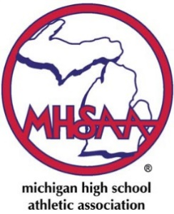
SCHOLARSHIP APPLICATION
*Applications deadline due April 30th*
This scholarship is open to any graduating child who’s coach
has been part of the coach’s association for the past year.

Applicant requirements:
- Minimum of one letter of recommendation from a teacher or coach
- 2 year member of varsity ski team
- Minimum GPA of 3.0

NAME of APPLICANT______________________________________ DATE______________

HOME ADDRESS_______________________________________________________________

CITY______________________________ZIP______________PHONE____________________

HIGH SCHOOL_________________________________________________________________

COACH’S NAME (Print) ________________________________________________________

E-MAIL_______________________________________________________________________

G.P.A. (unweighted)_______________ CLASS RANK _______ out of _____________

SAT______________________

On a separate sheet of paper BRIEFLY EXPLAIN YOUR:
CAREER PLANS:
ACADEMIC HONORS:
EXTRA-CURRICULAR SCHOOL, COMMUNITY ACTIVITIES, & SKI SUCCESS:

Signature ________________________________ | _________________________________
Applicant | Coach

YOU MUST INCLUDE A COPY OF YOUR TRANSCRIPT WITH THIS FORM

Email or Return to:
Craig McLeod
6601 Pine Ridge Drive
Clarkston, MI 48346
cjmcleod@gmail.com

